How to load the data from GCP to Snowflake Database?

How to export data from Snowflake to GCP (unloading)?

Prerequisite :

Sample Data loading

Step 1 : go to <https://www.kaggle.com/chetansharma0402/covid19-data-of-india>

Select <https://www.kaggle.com/chetansharma0402/covid19-data-of-india?select=covid_cases.csv>

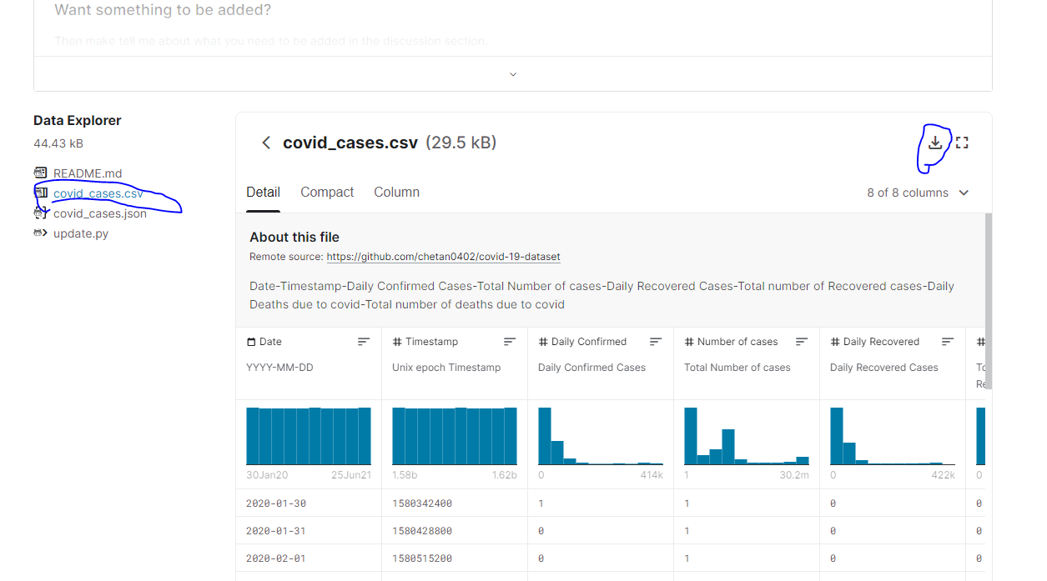

Download the file covid cases.

Step 2 :

Place the file at GCP location

Go to <https://cloud.google.com/>

Go to console



Go to storage

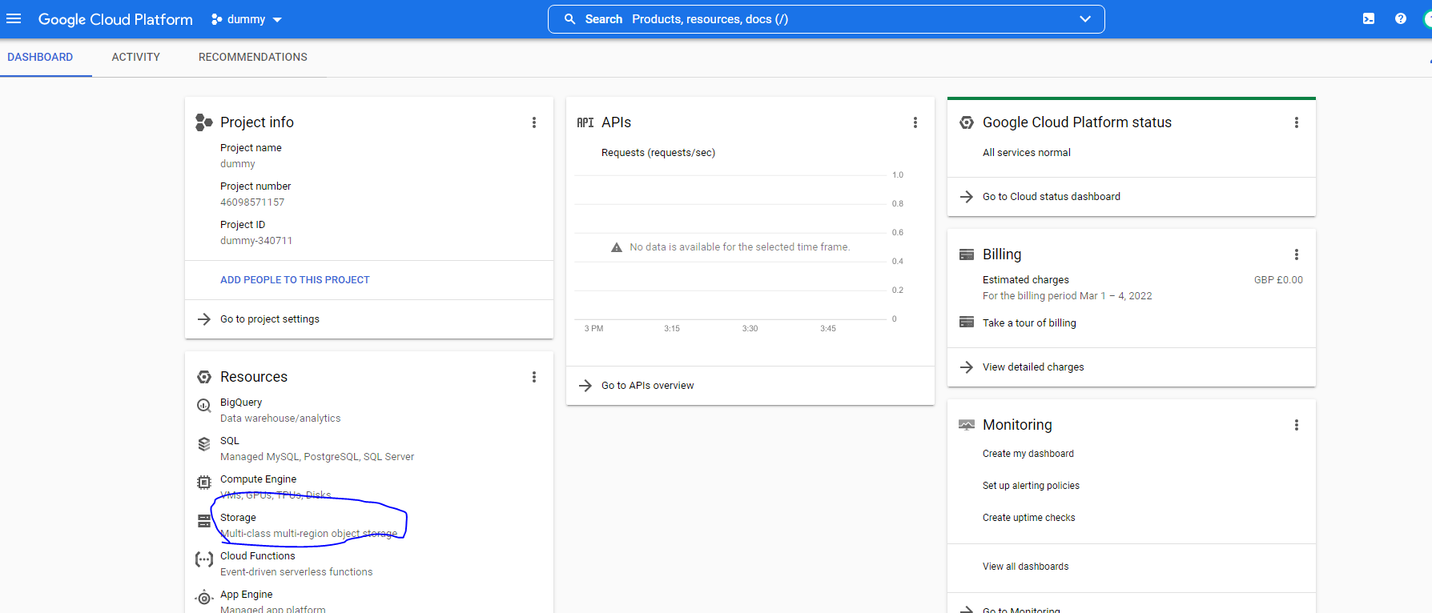

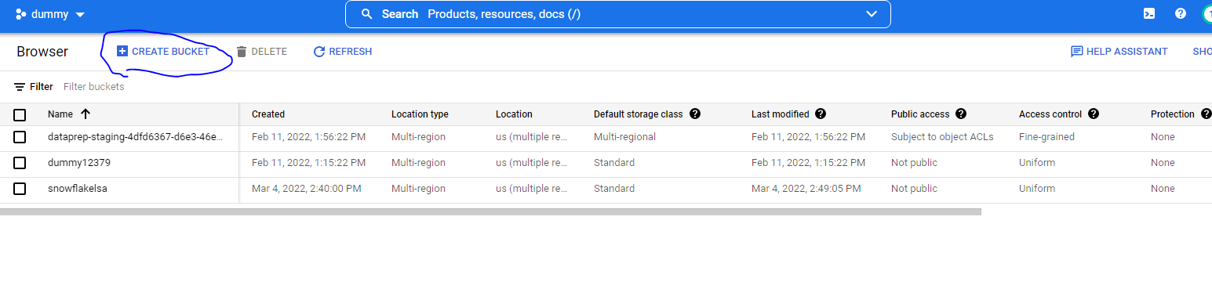

Give the name as Covidlsa and continue with the default steps.

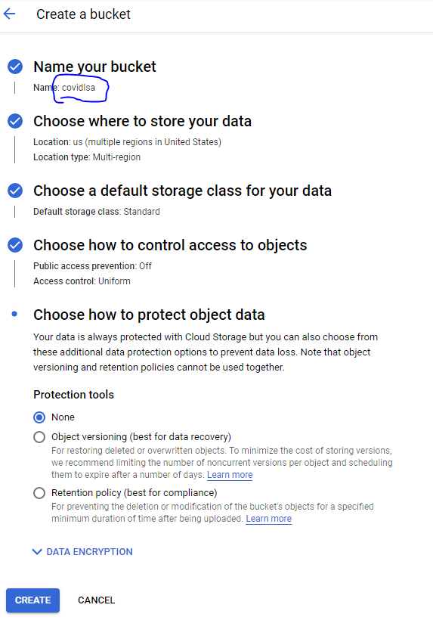

And create it after the creation will show like this.

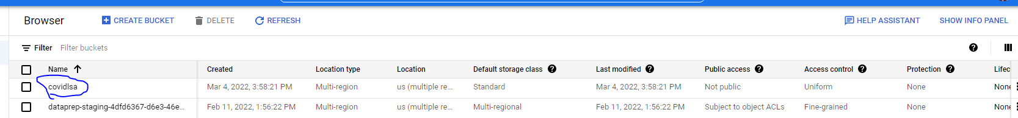

Place the file which we downloaded from the Kaggle.

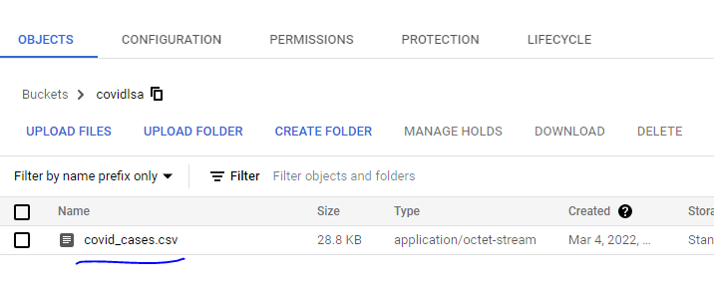

Login to snowflake :

Jump to demo db and public schema and user as account admin.

Create the storage object

create or replace storage integration gcs_covid_data

type = external_stage

storage_provider = gcs

enabled = true

storage_allowed_locations = ('gcs://covidlsa');

describe the object

DESC INTEGRATION gcs_covid_data;

Create the file format object

create or replace file format covid_cases_file

type = csv field_delimiter = ',' skip_header = 1 null_if = ('NULL', 'null') empty_field_as_null = true;

describe the file format object

desc file format my_csv_format;

Create the stage object in the combination of file format and storage.

create or replace stage gcs_data_movement

storage_integration = gcs_covid_data

url = 'gcs://covidlsa'

file_format = covid_cases_file;

add the permission to GCS storage account with the snowflake user and password

execute the strage object and copy the below details.

DESC INTEGRATION gcs_covid_data;

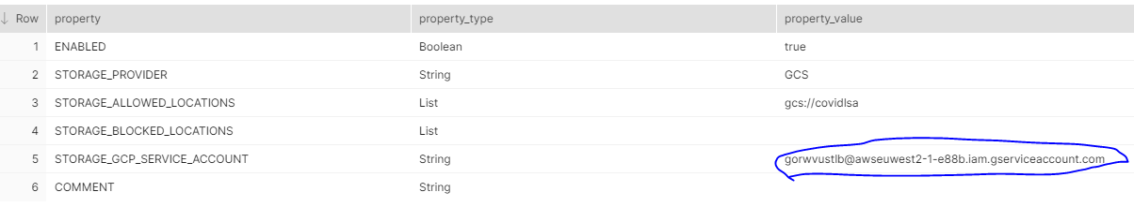

Copy the ~STORAGE_GCP_SERVICE_ACCOUNT~ and place at GCP permission bucket.

Go to GCP console / storage

Select covidlsa and permission.

Click and paste the GCP storage details

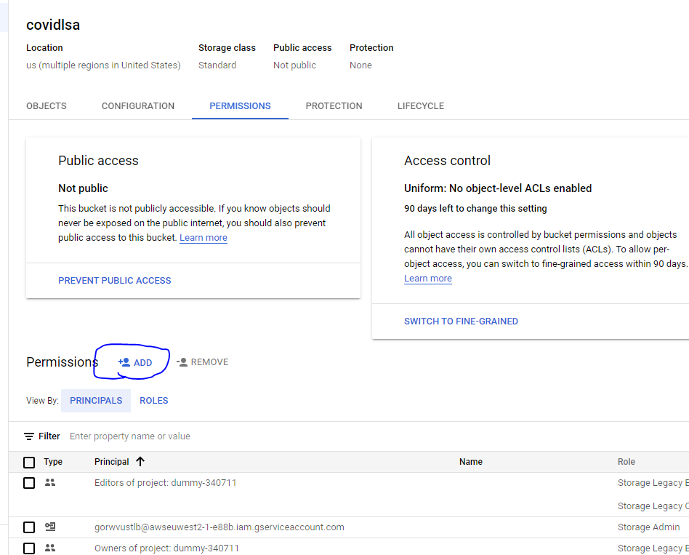

Execute the below sql to retrieve the data

create or replace table covid_cases as

select

t.$1 as Date,

current_timestamp as Timestamp,

t.$3 as Daily_Confirmed,

t.$4 as Number_of_cases,

t.$5 as Daily_Recovered,

t.$6 as Total_Recovered,

t.$7 as Daily_Deceased,

t.$8 as Total_Deceased

from @gcs_data_movement/ t;

select * from covid_cases ;